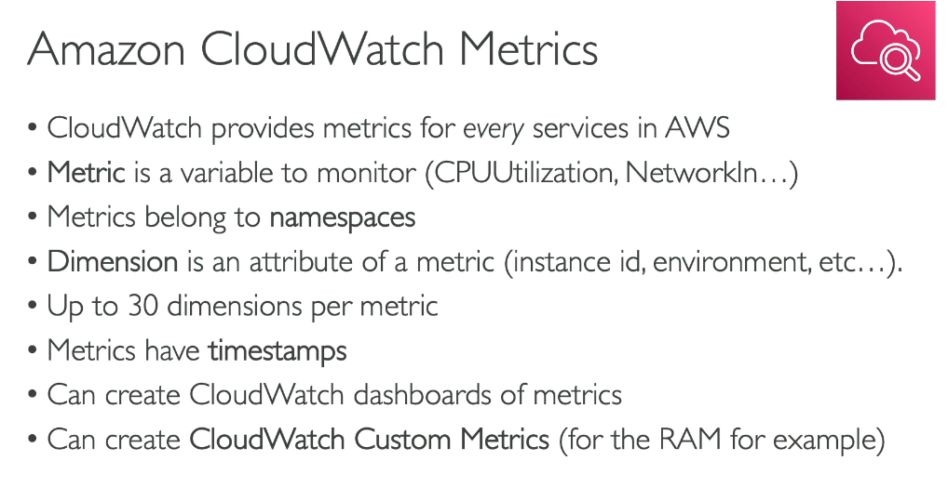

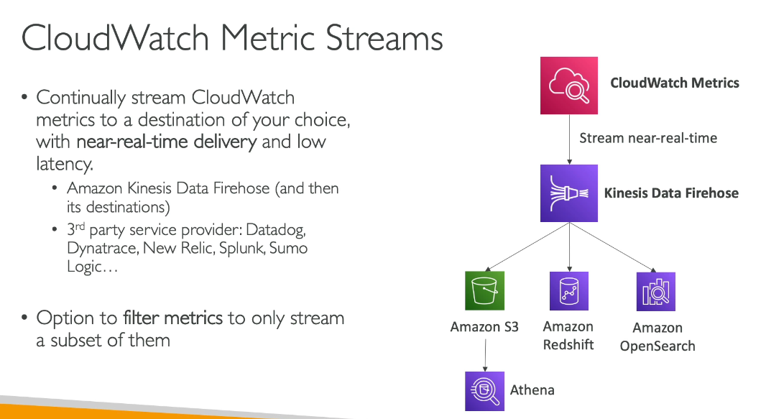

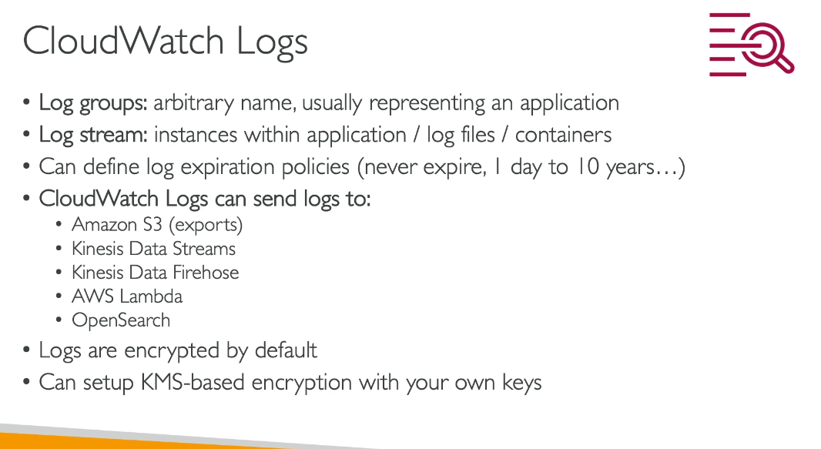

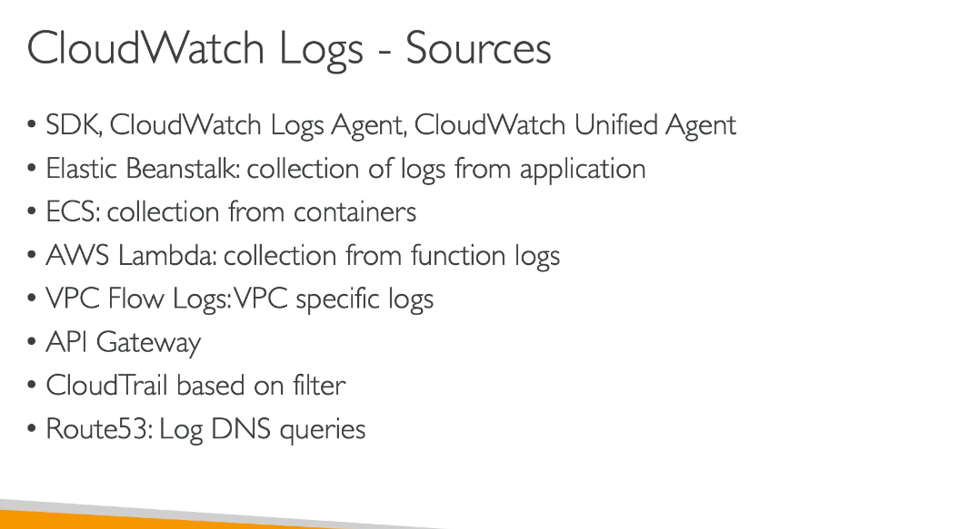

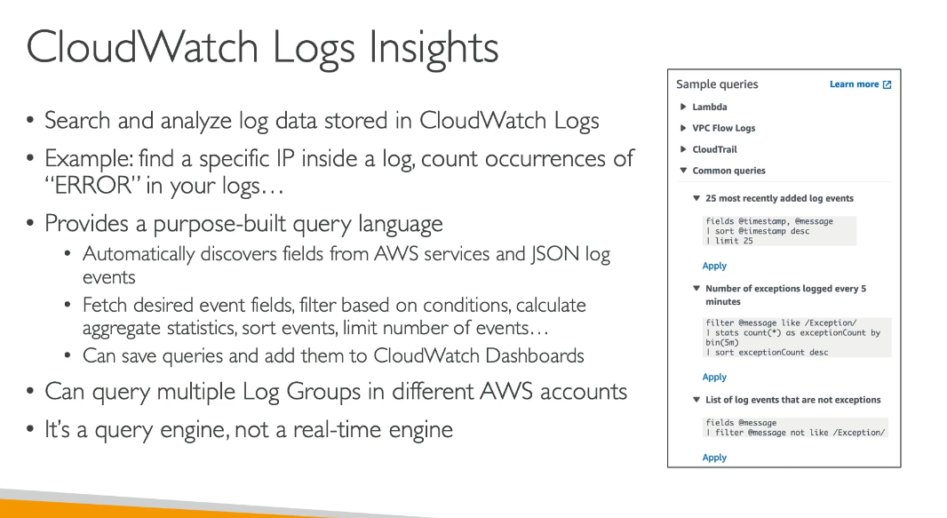

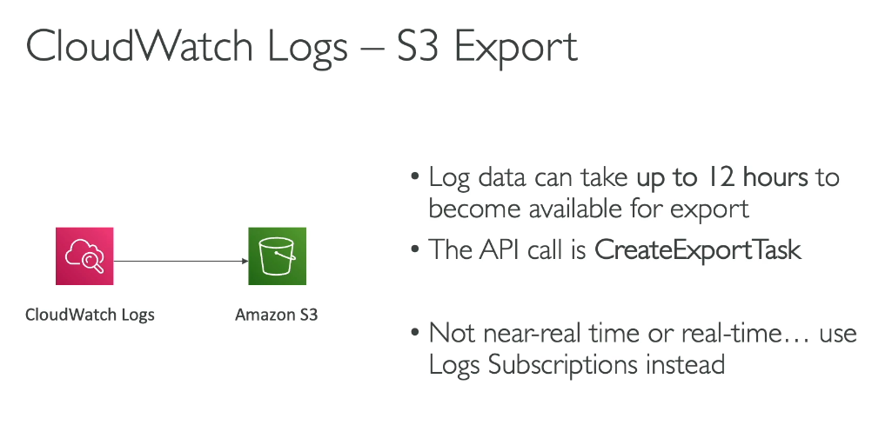

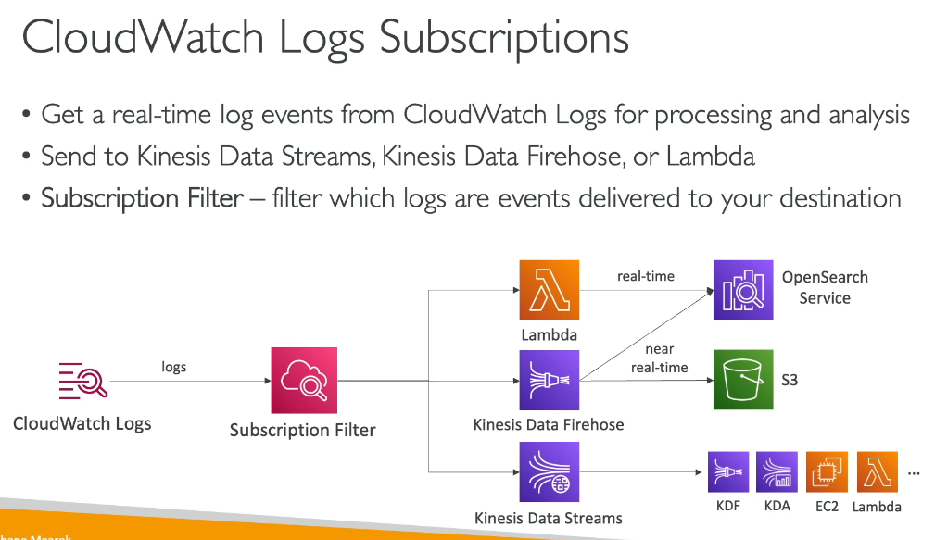

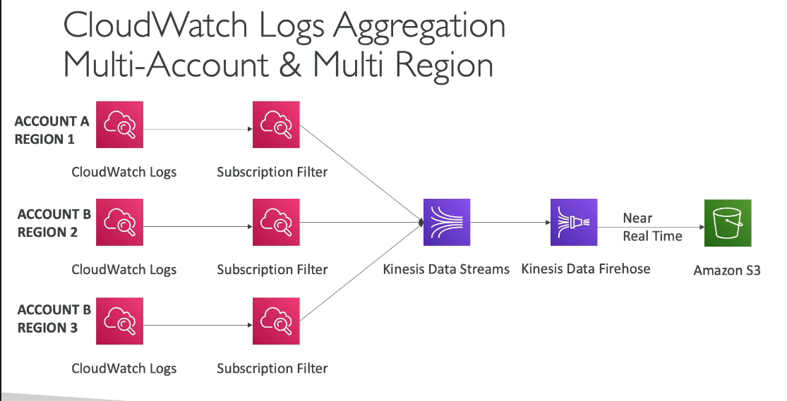

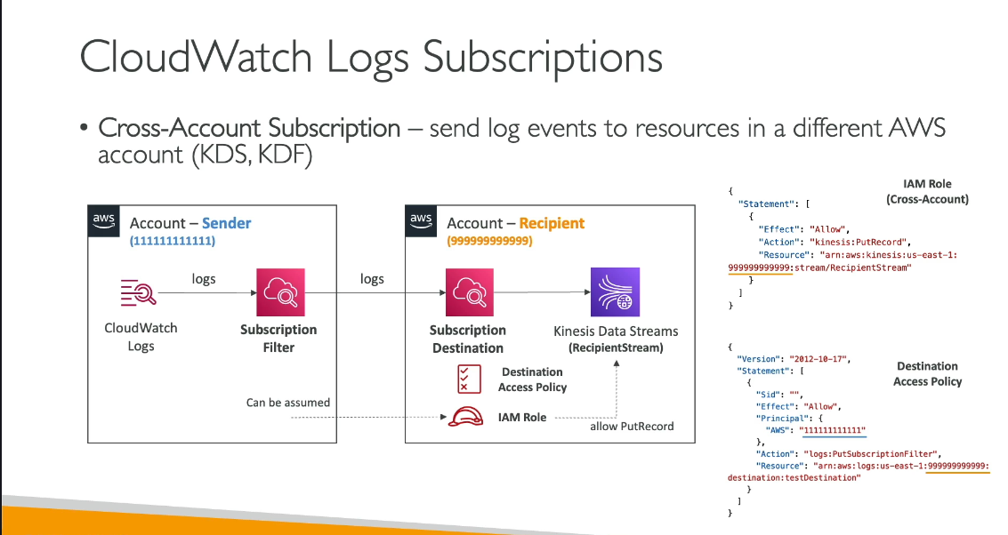

**Amazon CloudWatch Logs Live Tail** is an interactive analytics capability that provides a real-time view of your incoming logs. It allows you to view, filter, and highlight log events as they are ingested, helping you quickly troubleshoot issues and detect problems.

Key features:

* + Real-time streaming: View logs as they arrive in near real-time
  + Filtering: Filter logs based on specific terms you specify
  + Highlighting: Highlight logs containing specified terms to quickly find what you need
  + Interactive debugging: Test and validate code or configuration changes in real-time

Common use cases:

* + Developers can debug their code with a streaming view of logs
  + IT engineers can monitor deployment status and health
  + Operations teams can detect and debug failures more efficiently
  + Reduce mean time to detection (MTTD) and mean time to resolution (MTTR)

Important notes:

* + Live Tail is supported only for log groups in the Standard log class
  + Sessions incur costs based on usage time, per minute

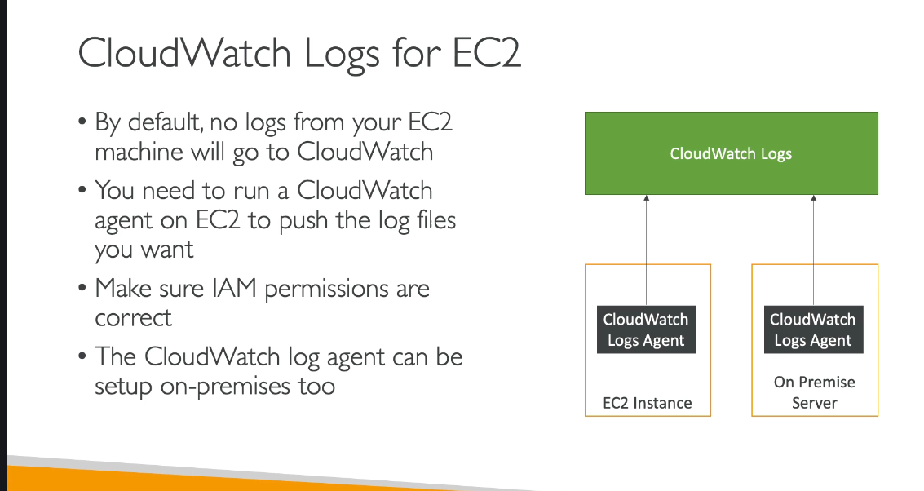

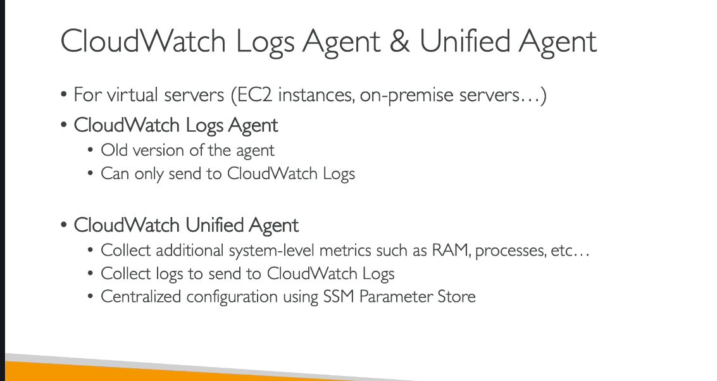

**CloudWatch Unified Agent SMM Parameter store feature?**  
**You store the agent’s config in one place (SSM Parameter Store) instead of editing config files on every server.**

Breakdown, no bullshit:

### **Without centralized config**

* You install the agent on 10 servers.
* You have to edit /opt/aws/amazon-cloudwatch-agent/etc/amazon-cloudwatch-agent.json  
   **10 times.**
* If you want to change something (add a new log file, new metric),  
   **you repeat the chore 10 times** or automate the mess.

→ That’s stupid, slow, and error-prone.

### **With centralized config (Unified Agent)**

* You store the config **once** in AWS Systems Manager Parameter Store.
* Every server pulls the config from that single location.
* You update it **once** → all agents fetch the new config and apply it.

→ Clean, consistent, scalable as f***.

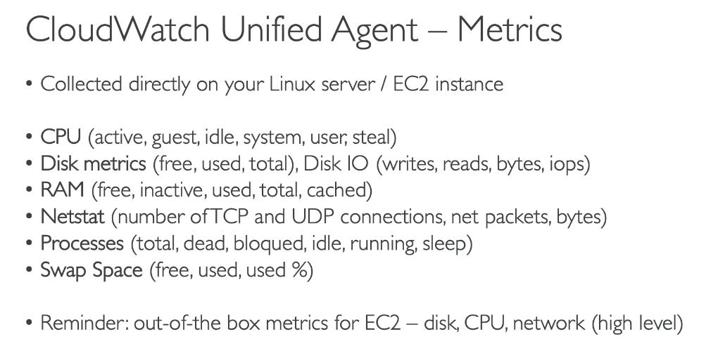

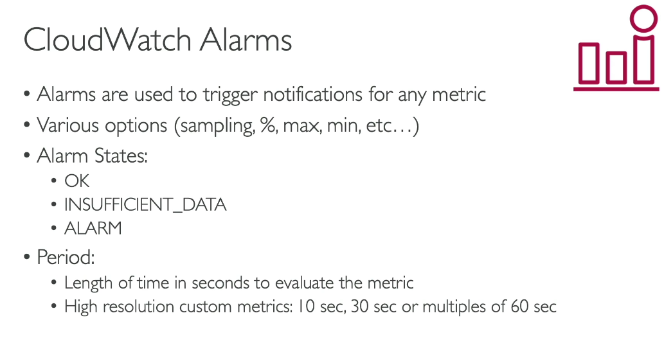

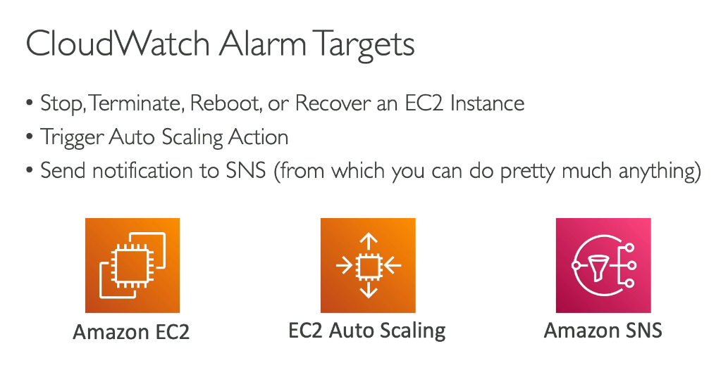

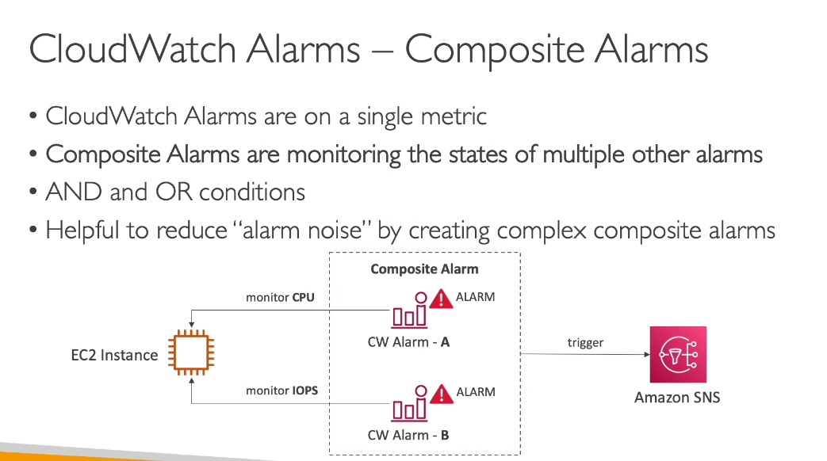

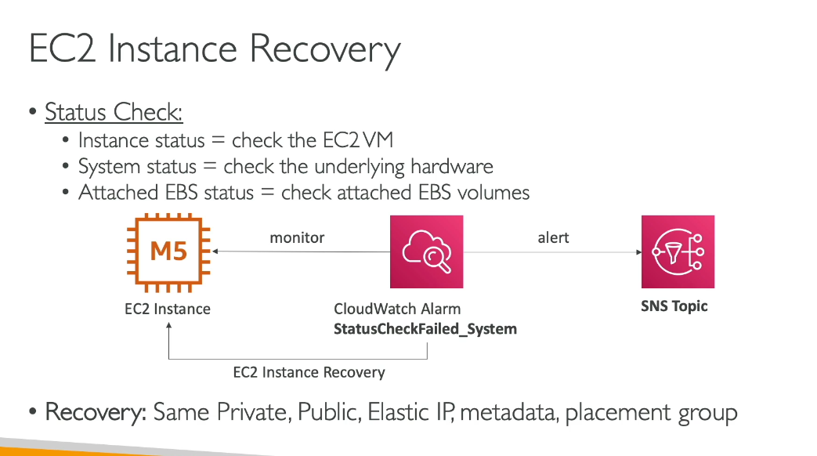

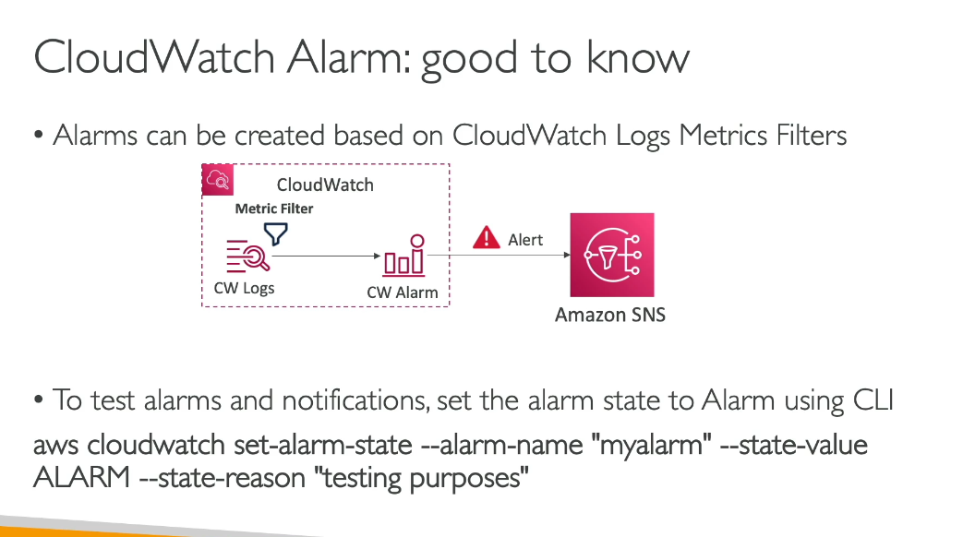

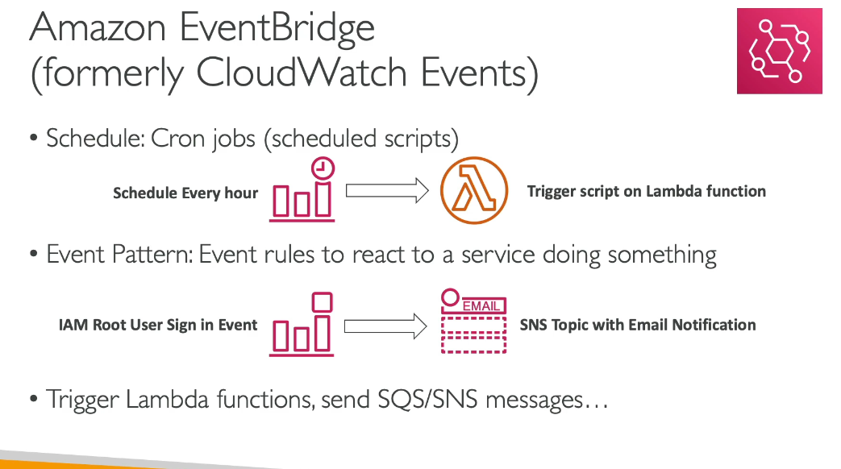

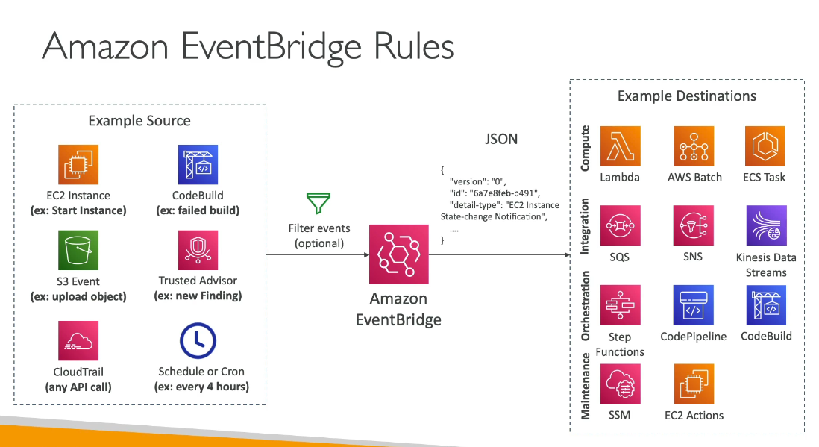

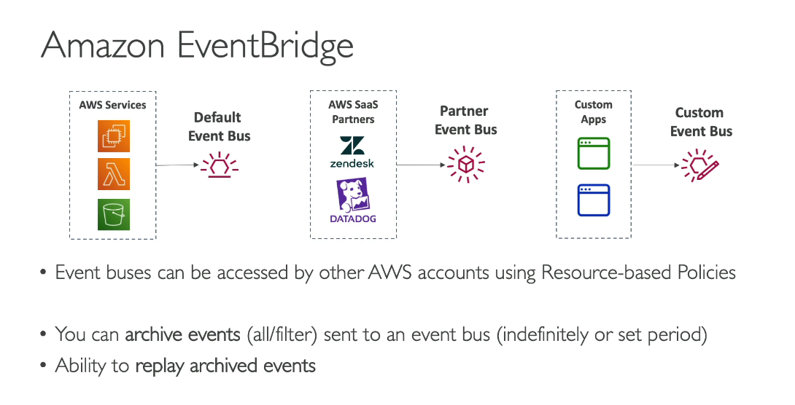

EventBridge Schema Registry is basically a catalog that stores the exact structure (schema) of every event that passes through EventBridge, so you don’t have to guess what fields a JSON event contains when writing code. EventBridge can automatically detect the schema from incoming events and save it, and you can then generate strongly-typed code (classes, interfaces, etc.) in your programming language so your application knows exactly what data to expect and can catch mistakes before runtime. It also versions schemas, so if an event format changes later you can stick to the old version or upgrade safely. In short: it gives events a defined blueprint and stops you from dealing with unpredictable, mystery-box JSON.

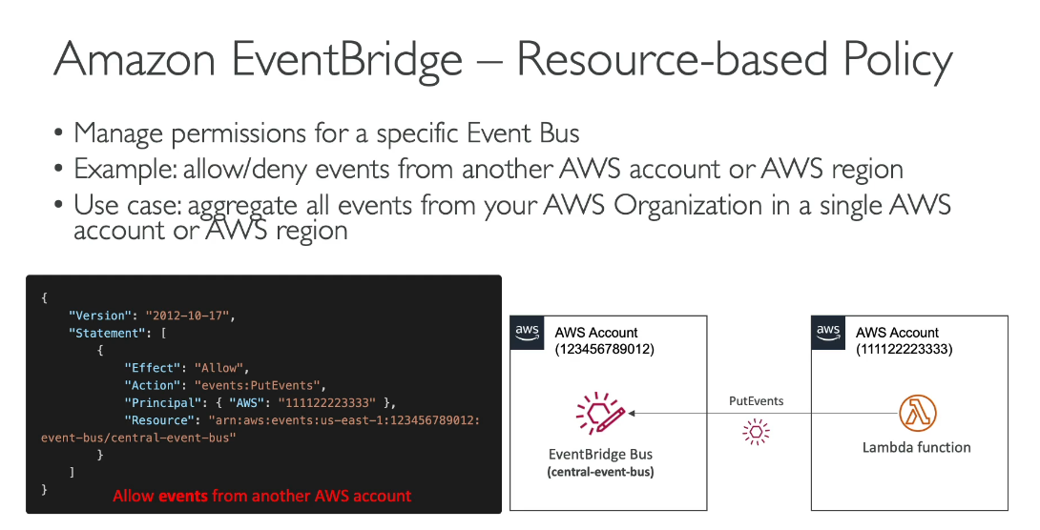

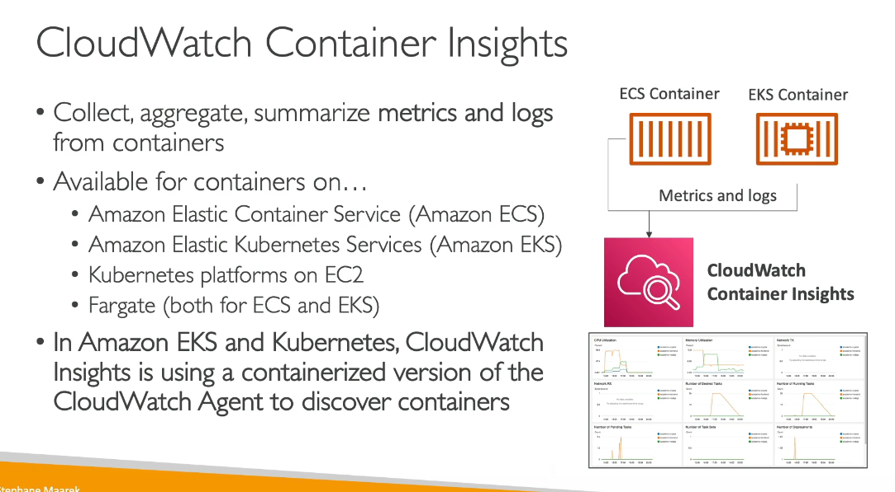

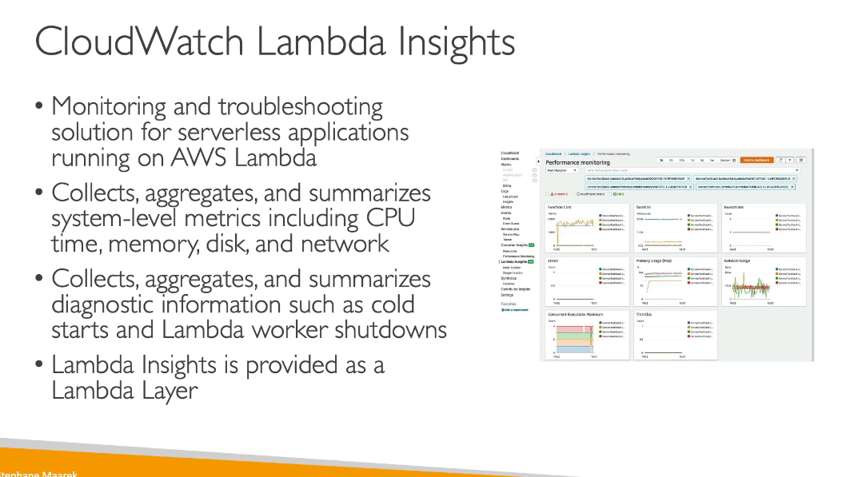

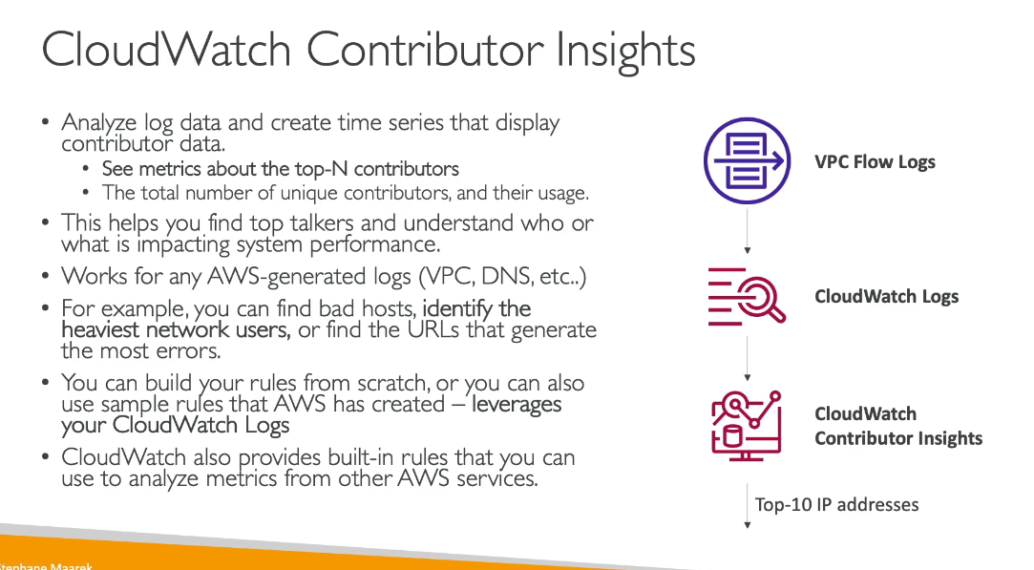

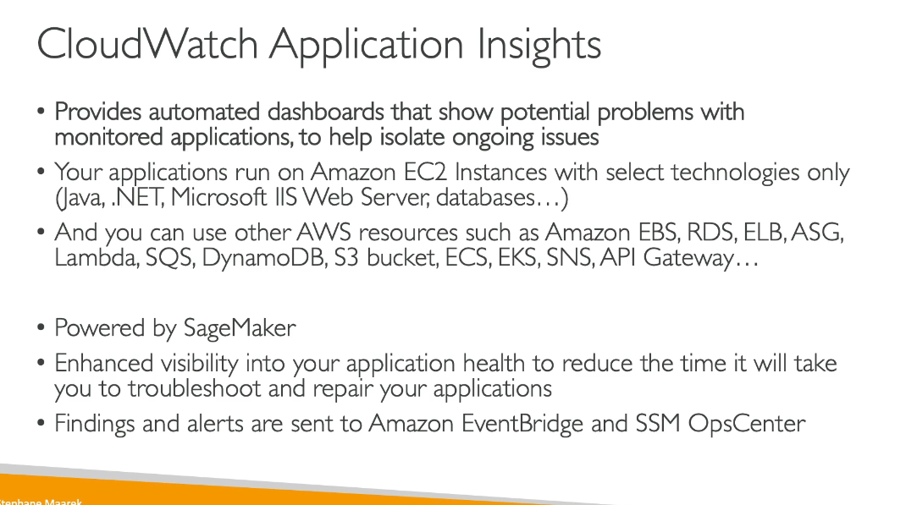

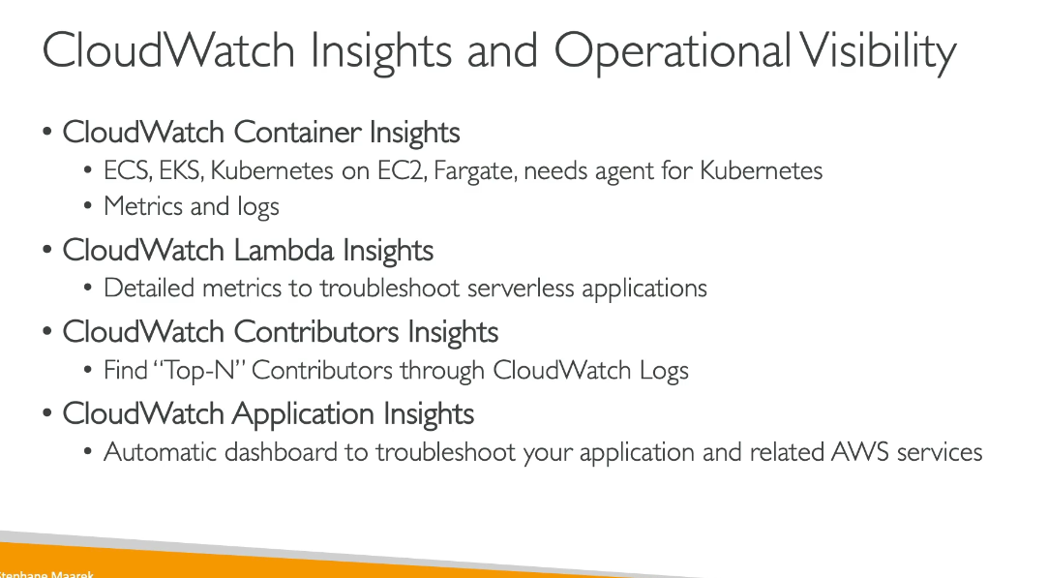

**Amazon CloudWatch Logs** **Insights** is an interactive log analytics service that enables you to search and analyze your log data in CloudWatch Logs. It helps you efficiently troubleshoot operational problems and understand application behavior.

Key capabilities:

* Query and analyze logs: Use a purpose-built query language to search through log data and extract meaningful information
* Visualizations: Automatically generates visualizations like bar charts, line charts, and stacked area charts from query results
* Fast performance: Queries run quickly even on large log datasets
* Pattern detection: Automatically discovers patterns in log data to help identify trends and anomalies
* Sample queries: Provides pre-built sample queries for common use cases to get started quickly

